**IREVOLUTION : A DATA – DRIVEN EXPLORATION OF APPLE’S IPHONE IMPACT IN INDIA**

**PROJECT REPORT**

Submitted to the Manonmaniam Sundaranar Univesity Tirunelveli, in partial fulfilment of the requirements for the award of the Degree in

BACHLEOR OF SCIENCE IN PHYSICS

by

**KARTHICK L (Reg. No 2021223152216)**

TEAM LEADER

**LAKSHMANAN M (Reg. No 20212231522119)**

**JEBIN FRANKO E (Reg. No 20212231522114)**

**KAVIBALA L (Reg. No 20212231522117)**

TEAM MEMBERS

Under the Guidance of

Dr. S. Subramanian

Assistant Professor



DEPARTMENT OF PHYSICS

V. O. CHIDAMBARAM COLLEGE

THOOTHUKUDI – 628 008.

OCTOBER – 2023.

**ACKNOWLEGEMENT**

Adores our heart humbly silently & gratefully reflecting the will & Blessings showed by our Lord Almighty who made us turn every challenge in to success till this day of seeing our project work in print.

With a deep sense of gratitude we express our sincere thanks to our project supervisor **Dr.** **S. Subramanian Assistant Professor** for his valuable guidance & constant encouragement in completing this project work.

I would like to thank our **H.O.D. Dr.** **John Prince Soundranayagam**  **Associate Professor** for his valuable advices whenever we approached him.

I also express our gratefulness to **Dr. C. Veerabahu M.Sc., Ph.D., The Principal,** for giving us the permission to do the project work.

We also express our sincere thanks to **Dr. K. Amudhavalli, Dr. M. Nagarajan, Prof. A. Infantia Daphne and Prof. S. Subha**, Department of Physics for their encouragement &suggestions throughout the course of study.

We would like to express our heartfelt thanks to **Mr. Teles Rayer, Mr. K. Veerabagu and Mr. Rajesh**, Lab Assistants for their valuable help.

I am greatly indebted to **our parents & family members, friends** for their moral support which helped us to complete this work.

**INTRODUCTION**

The world has changed as a consequence of the increasing use of smartphones, which have improved communication, connected people, and revolutionized many different businesses. With its main product, the iPhone, capturing markets around the world, Apple Inc. has emerged as a prominent player among the top smartphone makers. India, one of the economies with the greatest economic growth, has seen a tremendous increase in smartphone usage, making it an interesting market to study the effects of Apple's iPhone.

In order to shed light on important factors like market penetration, customer preferences, economic ramifications, and societal changes, this research report will perform a data-driven investigation of the impact of the iPhone in India. This study will offer invaluable insights into the transformative impact of the iPhone on India's technological landscape and the lives of its consumers by using advanced data analytics techniques and analyzing large datasets.

Apple has a special chance to increase its market share and develop a significant presence in India thanks to the country's large population and rising smartphone adoption. Each new iPhone model unveiling generates excitement and anticipation among Indian buyers. By utilizing the plethora of information

Already accessible, this research aims to go beyond conjecture and anecdotal evidence in order to develop a thorough knowledge of the effects of the iPhone.

* Empathy Map
* Brain Storming And Idea Prioritization
* Visualizations of KPI
* Market Penetration (iPhone)
* Model Specification
* Battery Type Distribution
* Brand Price Comparison
* Model-Share
* Country wise best selling smartphone
* Quarterly-Share
* Annual Revenue
* Global Market Share

**PROJECT FLOW**

* Empathy Map
* Brain storming and Idea Prioritization
* Data Preparation

Prepare the Data for Visualization

* Data Visualizations

No of Unique Visualizations

* Dashboard

Responsive and Design of Dashboard

* Story

No of Scenes of Story

* Performance Testing

Amount of Data Rendered to Tableau

* Publishing

Publish Dashboard & Story to Tableau Public

* Project Demonstration & Documentation

Record explanation Video for project end to end solution Project Documentation-Step by step project development procedure

**EMPATHY MAP**

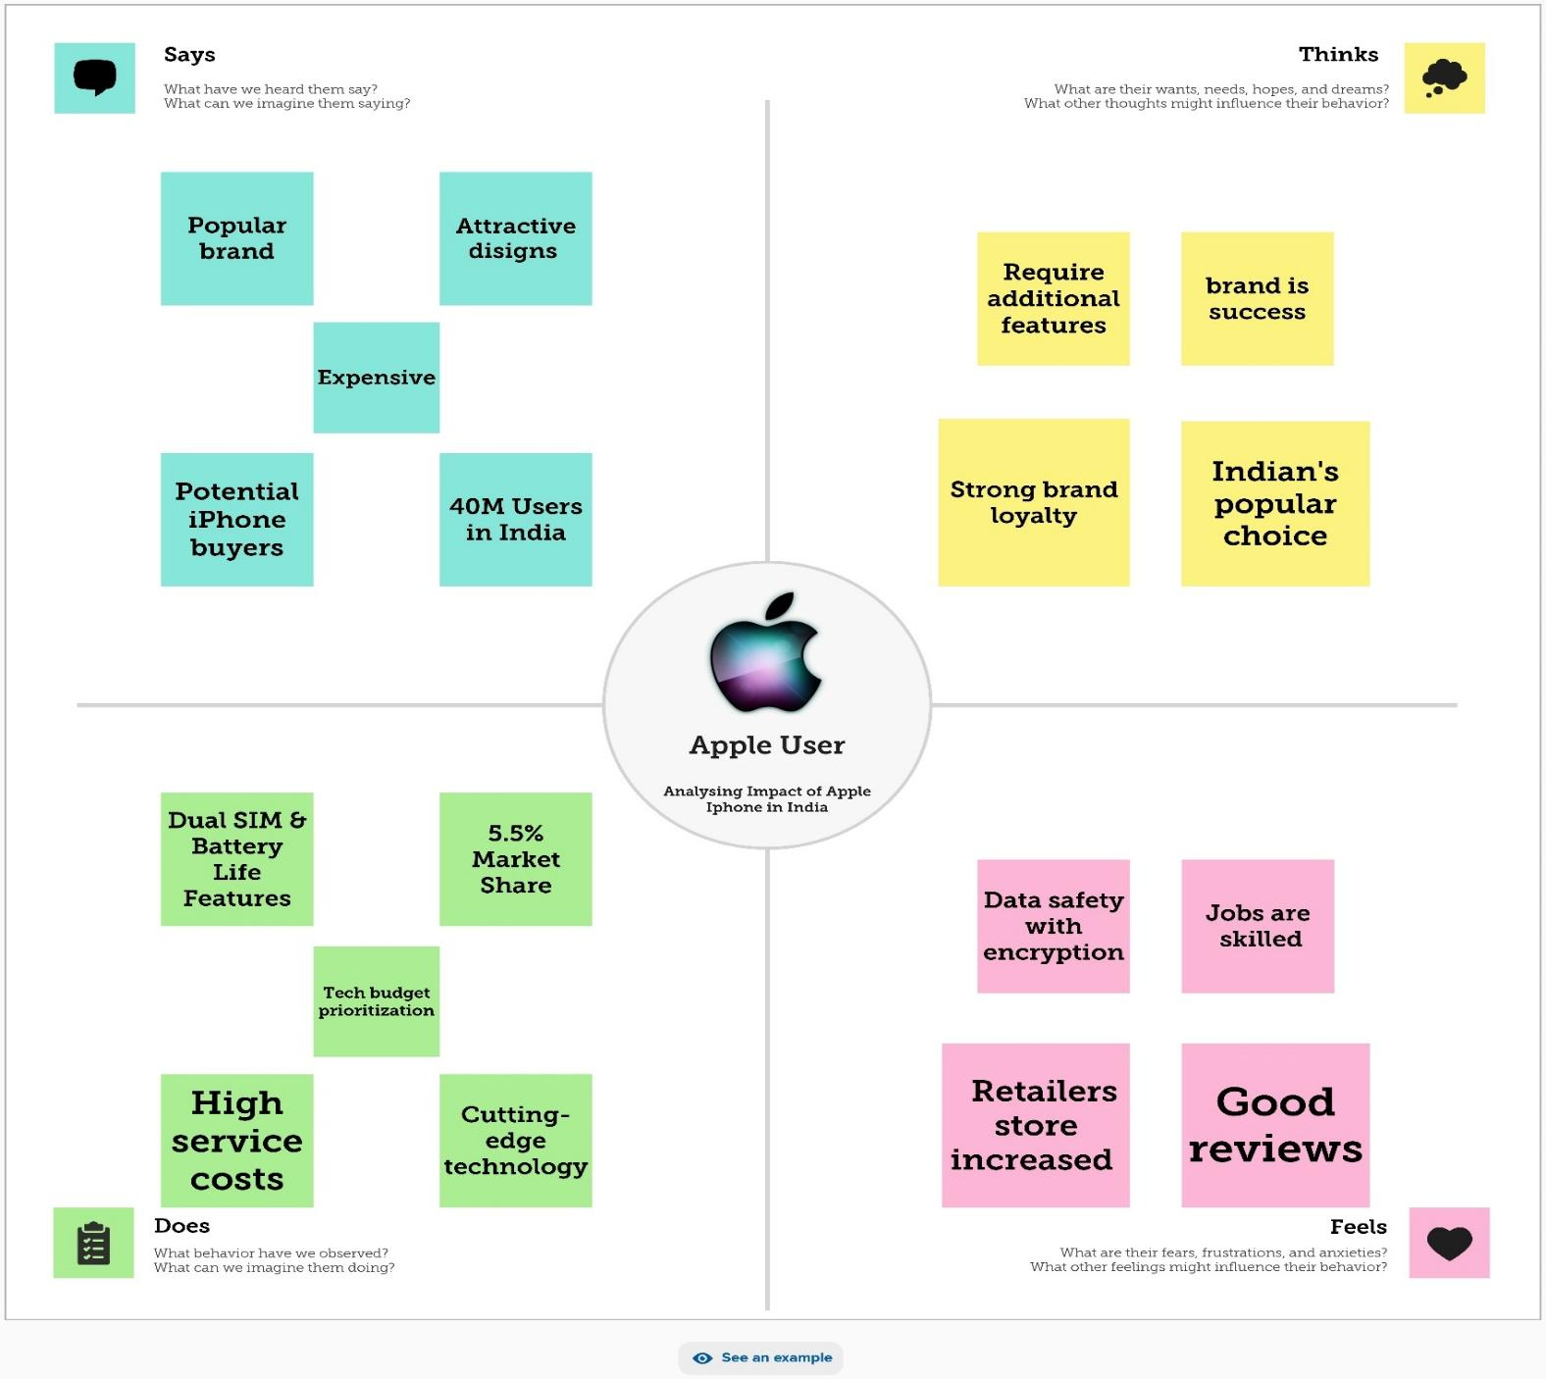

**BRAIN STORMING AND IDEA PRIORITIZATION**

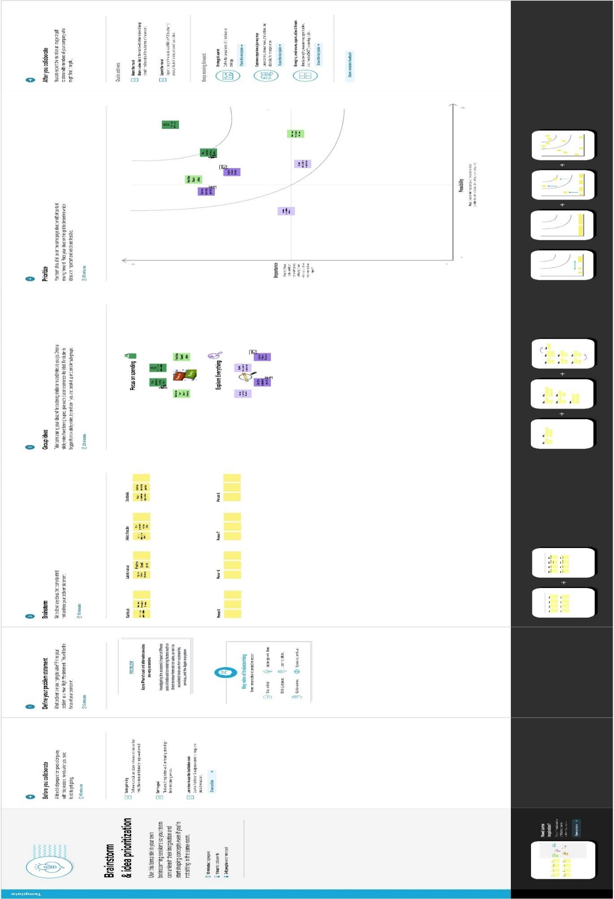

**DATA PREPARATION**

Preparing the data for visualization involves cleaning the data to remove irrelevant or missing data, transforming the data into a format that can be easily visualized, exploring the data to identify patterns and trends, filtering the data to focus on specific subsets of data, preparing the data for visualization software, and ensuring the data is accurate and complete. This process helps to make the data easily understandable and ready for creating visualizations to gain insights into our analysis.

**DATA VISALIZATION**

Data visualization is the process of creating graphical representations of data in order to help people understand and explore the information. The goal of data visualization is to make complex data sets more accessible, intuitive, and easier to interpret. By using visual elements such as charts, graphs, and maps, data visualizations can help people quickly identify patterns, trends, and outliers in the data.

**SHEET 1 – Key Performance Indicator**

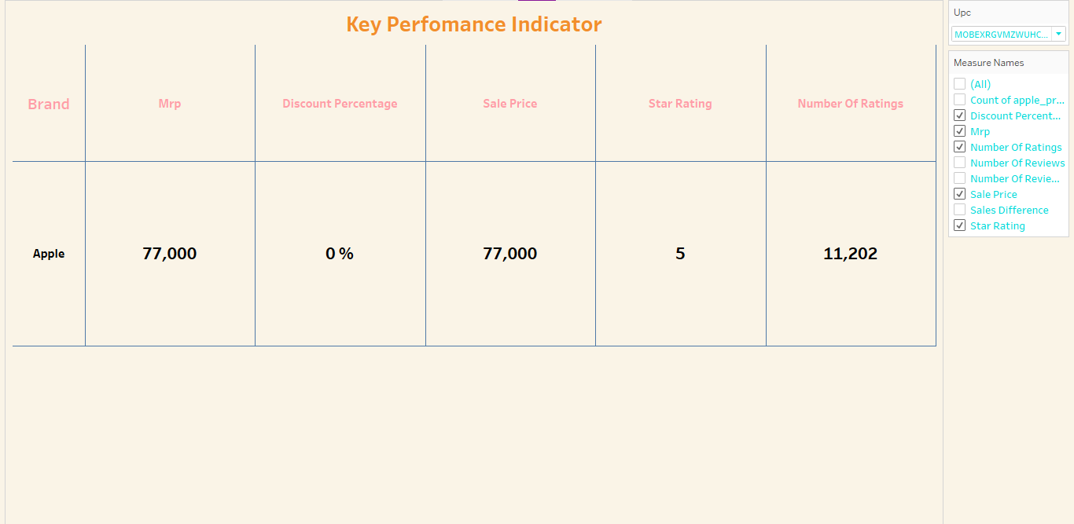

Visualizations of Brand and it’s selling measures.

**SHEET 2 – Market Penetration (iPhone)**

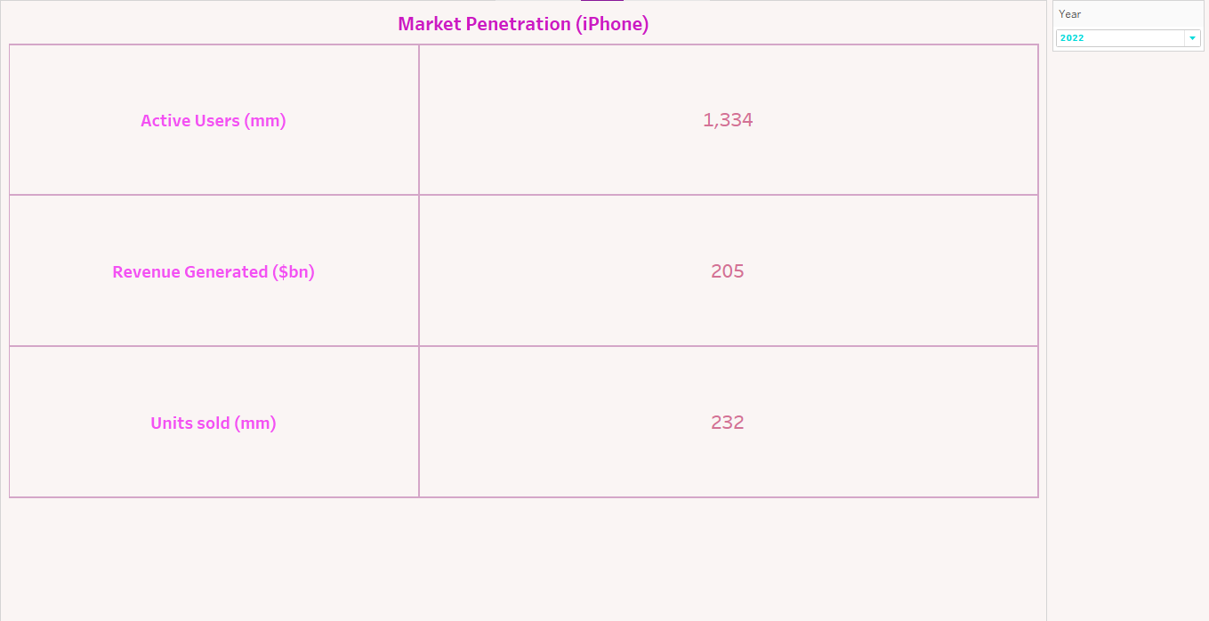

The market penetrations like how many users , revenue generated and units sold of Apple iPhone according to the years.

**SHEET 3 – Modal Specification**

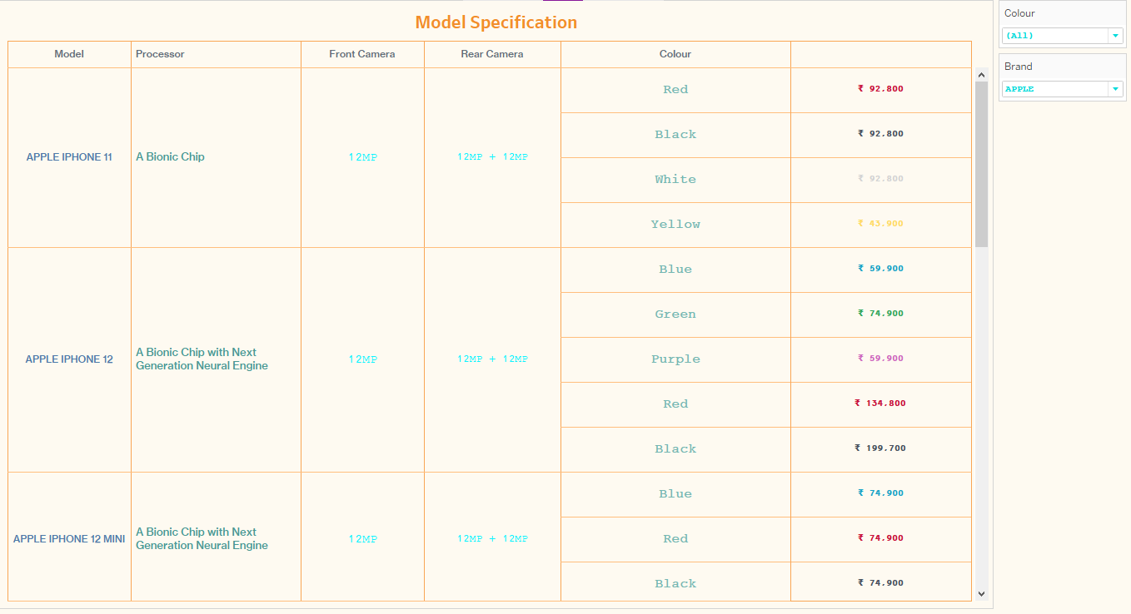

We visualized about the processor, camaras and colour of a specific model of brands.

**SHEET 4 – Battery Type Distribution**

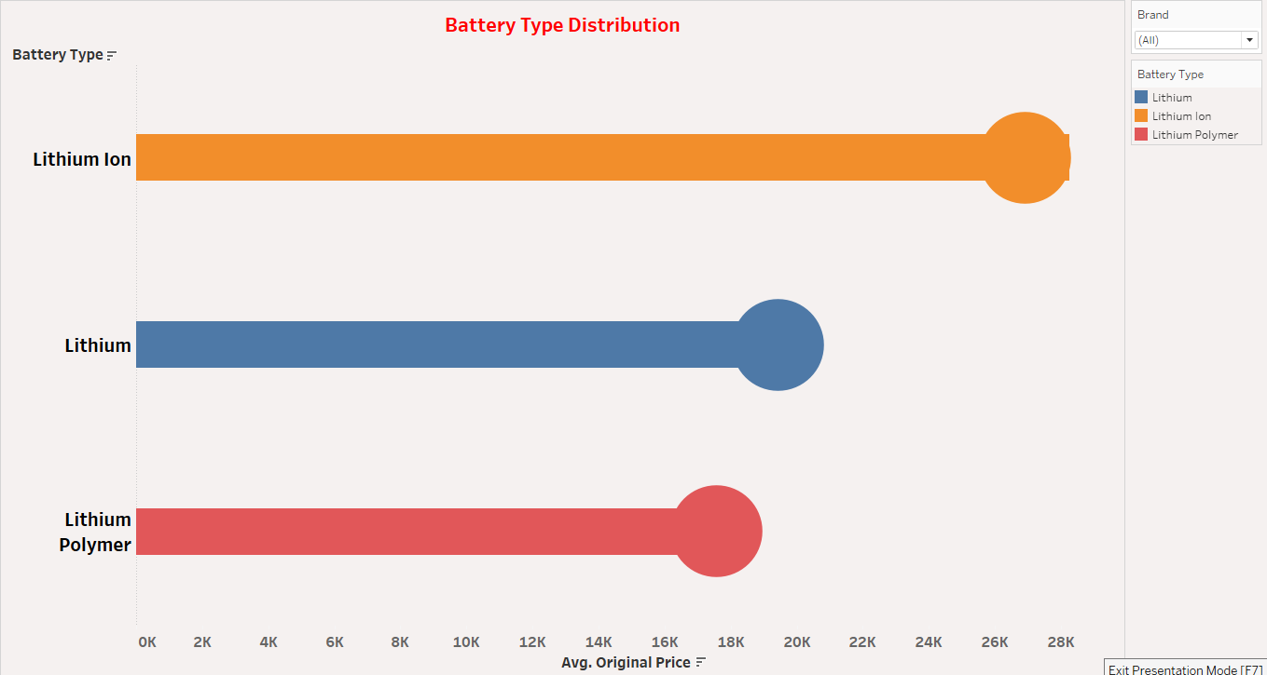

We showed the type of batteries used in specific Brands.

**SHEET 5 – Brand Price Comparison**

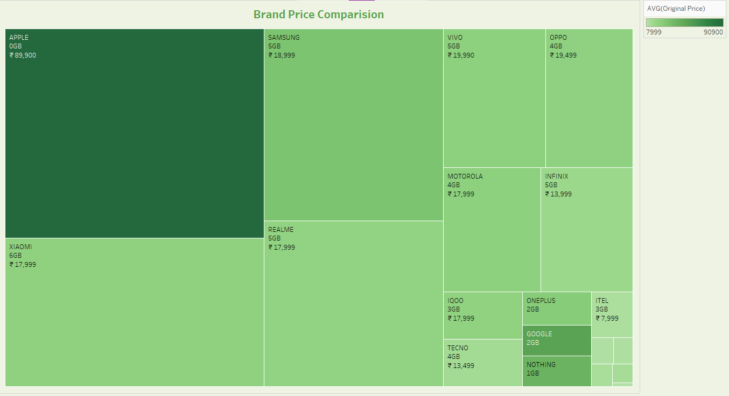

Here overall high Price Brands are highlighted by dark green colour and we can see apple is highest one.

**SHEET 6 – Model-Share**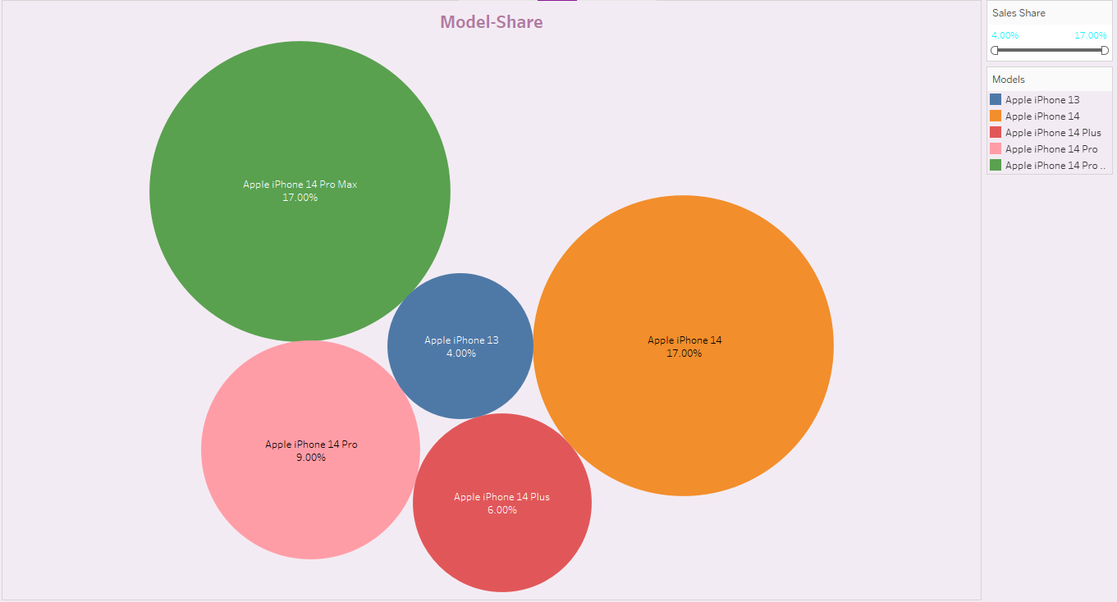

We compared different apple iPhone brands with their model shares.

**SHEET 7 – Country wise best selling smartphone**

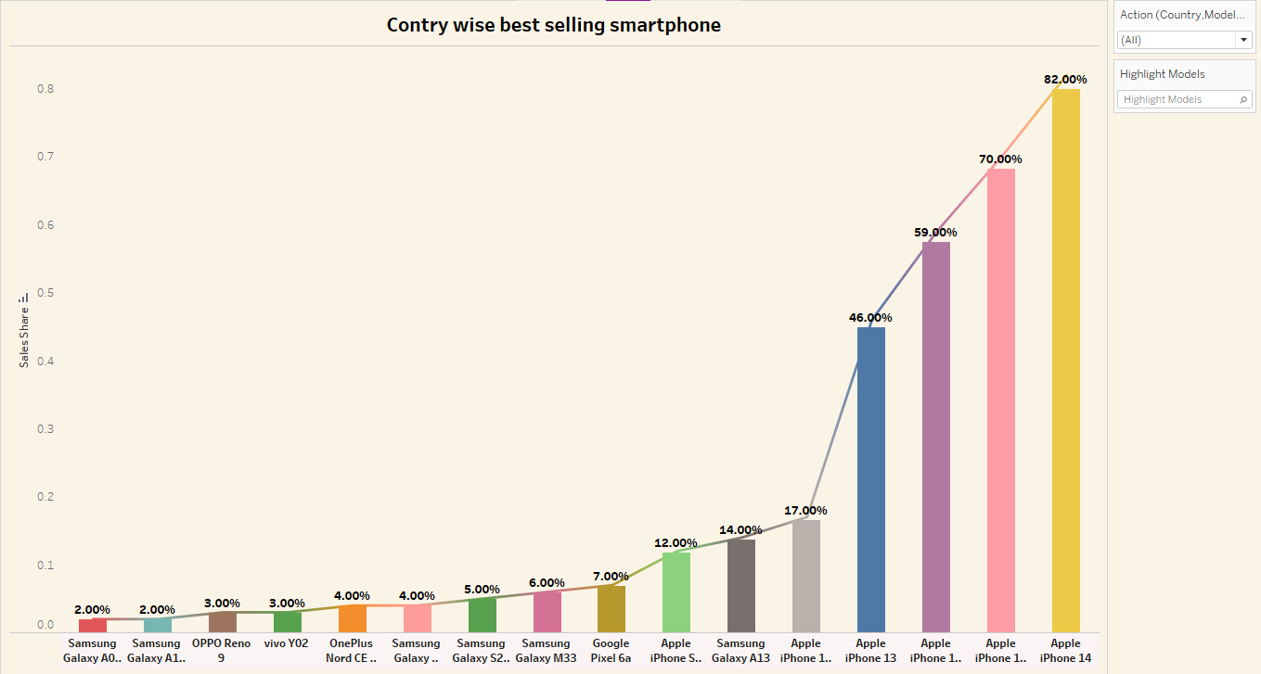

Country wise selling best smartphones are compared according to their sales share and here also iPhone has lots of sales shares.

**SHEET 8 – Quarterly-Share**

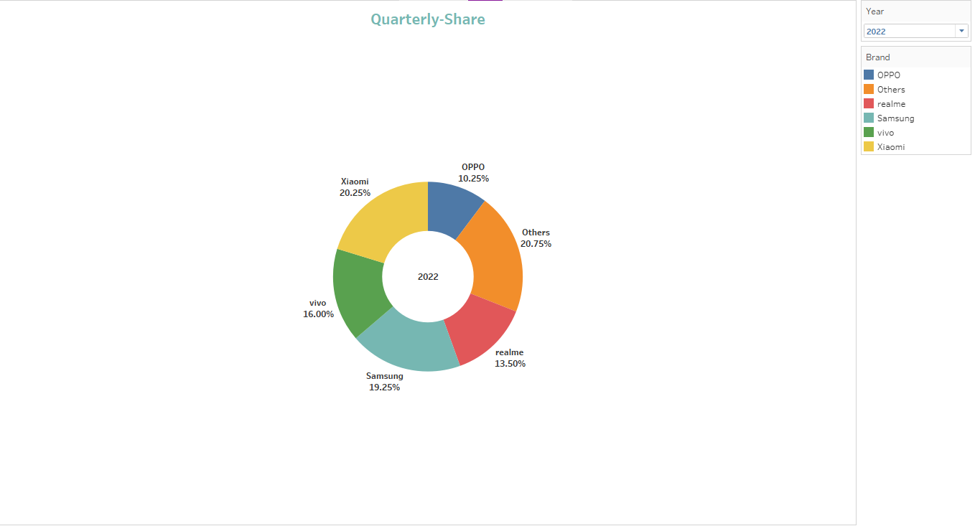

The quarterly share is shown in a doughnut chart of different brands according to year.

**SHEET 9 – Annual Revenue**

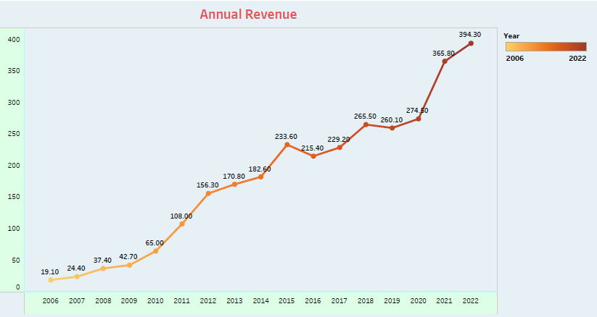

We have drown graph of annual revenue of iPhone over the years.

**SHEET 10 – Global Market Share**

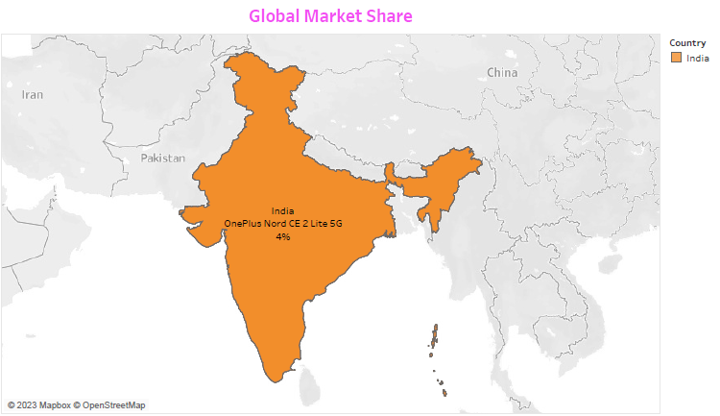

We have mentioned the global market shares of different countries in the map.

**DASHBOARD**

A dashboard is a graphical user interface (GUI) that displays information and data in an organized, easy-to-read format. Dashboards are often used to provide real-time monitoring and analysis of data, and are typically designed for a specific purpose or use case. Dashboards can be used to track key performance indicators (KPIs), monitor performance metrics, and display data in the form of charts, graphs, and tables.

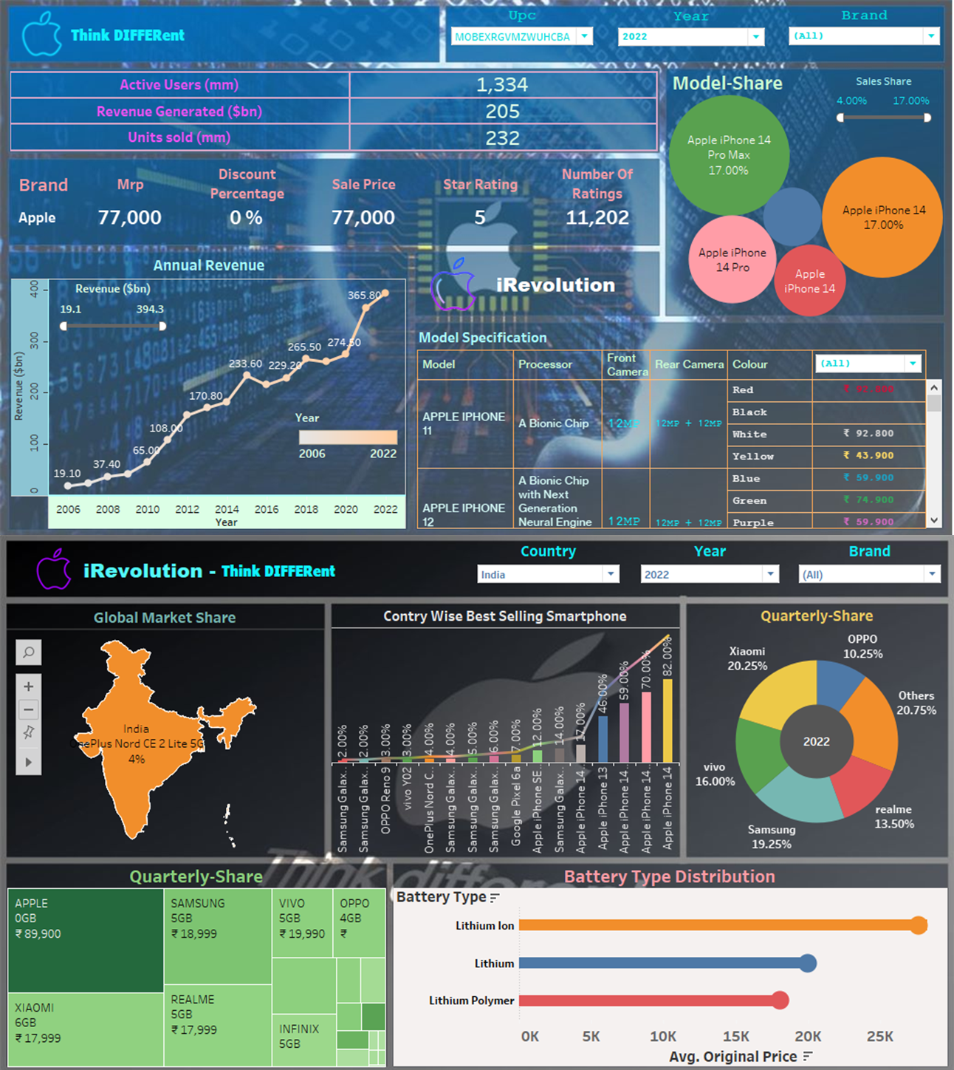

**STORY**

A data story is a way of presenting data and analysis in a narrative format, with the goal of making the information more engaging and easier to understand. A data story typically includes a clear introduction that sets the stage and explains the context for the data, a body that presents the data and analysis in a logical and systematic way, and a conclusion that summarizes the key findings and highlights their implications. Data stories can be told using a variety of mediums, such as reports, presentations, interactive visualizations, and videos.

The below is the link for story.

https://drive.google.com/file/d/1b07WdLRO6okXW5HshceRQeswKmjkLEdZ/view?usp=drivesdk

**Publish Dashboard & Story to Tableau Public**

We have published the results of our analysis in Tableau Public and given the link below.

<https://public.tableau.com/app/profile/karthick.l8283/vizzes>

**PROJECT DEMONSTRATION**

Video explanation of our work have been recorded and the link for access is given here.

<https://drive.google.com/file/d/1axCSXfN-_ScS5gvT1FrZmoRZQ9o1dH_U/view?usp=drivesdk>

**RESULTS AND DISCUSSIONS**

We have studied the Apple's iPhone Impact In India

by creating Charts

* Empathy Map
* Brain Storming And Idea Prioritization
* Visualizations of KPI
* Market Penetration (iPhone)
* Model Specification
* Battery Type Distribution
* Brand Price Comparison
* Model-Share
* Country wise best selling smartphone
* Quarterly-Share
* Annual Revenue
* Global Market Share

**THANK YOU**